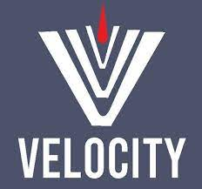 **---------------------------------------------------------------------**

**Manual Testing by Vaibhav Sir**

**---------------------------------------------------------------------**

**Contents Page No.**

1. Syllabus 02
2. Team 03
3. SQA 03
4. SDLC 04
5. Fish Module 07
6. Waterfall Model 09
7. V-Model 10
8. Agile Model 13
9. Agile Meetings
10. Technology used in Project
11. Environment
12. Unit Testing and Integration Testing
13. Sanity/Smoke Testing
14. System and Functionality Testing
15. Functional Testing
16. Non Functional Testing
17. Security and Performance Testing
18. Retesting and Regression Testing
19. User Acceptance Testing
20. Monkey Testing, Exploratory Testing, Adhoc Testing.
21. Priority and Severity

**Syllabus**

**Manual Testing – I.**

* Software Development Life Cycle.
* Waterfall Model.
* V-Model.
* **Agile Model/Agile Methodology (90-95% Used in Project)**

**Types of Testing**

* Sanity / Smoke Testing
* System and Functionality Testing
* Usability Testing
* Retesting and Regression Testing

**Manual Testing – II.**

**Real Time Part –** Test Case Design, Test Case Execution, Test Case Review, Defect Logging, User Story Understanding.

**Database Testing.**

**SQL Language | Application – Oracle Live etc**

**API / Web Service Testing.**

SOAP and REST Services  
Tool – Postman

**JIRA – Project Management Tool.**

**2 Live Projects.**

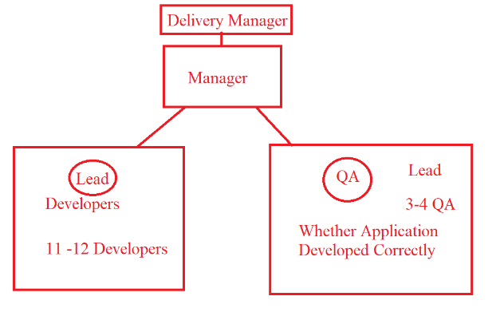**Teams**

**Project Team.**

* **Delivery Manager (1)** – Project Deliver to Client.
* **Project Manager (1)** – Manage the Project (Handle the Dev and Testing Team)
* **Business Analyst (1)** – Interact with Client related to Clients Requirement.
* **Designer / Design Architect (1)** – Lead of the Dev Team. – Project Design
* **Development Team (10/11/12 Dev**) – Project Coding / Dev the Application.
* **Testing Team (3/4 QA)** – Test the Application.

**Support Team.**

* **Support Team will work on the existing issue /Tickets raised by the client.**
* **Project Team(1) –** will manage the project work
* **Developer Team (2-3) –** Manage Coding Part
* **Testing Team (1) –** Test the Application.

**What is Your Team Size? 🡪 18 People.**

**In which team you have worked? 🡪 Project Team.**

**Software Quality Assurance (SQA)**

* SQA is a process used to **measure and monitor** the development and testing of the application.
* SQA is done by **BA.**

**SQA Considers**

1. **Client’s/Customer’s Requirements:** The requirement fill full to the client e.g Project is Banking / e-Commerece / Healthcare etc domain.
2. **Client’s/Customer’s Expectations :** Suppose Team is developing Banking ATM related Project – ( Privacy : Personal Data should be kept private/Secured)
3. **Cost / Budget of the Project :**

Estimation /Cost required for completing the Client’s Application

E.g (12 Dev + 3 QA * 2000)

1. **Delivery / Deployment Time (Duration).**

In How many Days/Weeks/Months/Years will team complete the Application?

1. **Risk in the Project.**

What if our company fail to deliver project within given time.  
Government MPSC Exam – Online – 10 Oct – Deadline 07 Oct Product Application should be ready. IF Application is not ready till 10 Oct-🡪 Exam Cancelled 🡪 That Risk factor discussed in this phase.

1. **Maintenance.**

(1-2 Month)

What is SQA?

Explain the SQA.

**Software Development Life Cycle.**

1. **Information Gathering.**
2. **Analysis.**
3. **Design(High Level / Low Level)**
4. **Coding**
5. **Testing**
6. **Support / Maintenance**
7. **Information Gathering (BA) (BRS)**

* In the information gathering is done by BA.
* In the information gathering stage, BA collects all the requirements related to the **client business.**
* After collecting all the Business related requirements BA will prepare **BRS (Business Requirement Specification) document.**
* BRS is a Company level document, Dev and QA don’t have access of it.
* E.g Hotstar App – Business 🡪 Collect Subscription Amount from the End Users.

1. **Analysis (BA) (SRS)**

* Analysis is done by BA.
* In the Analysis phase BA Collects are the information / requirement related to the **Client’s Application (Software Specification).**
* Based on the software requirements BA prepares the **SRS (Software Requirement Specification) Document.**
* SRS is also known as FRS – Functional Requirement Specification / CRS – Customer Requirement Specification.
* Once SRS document is prepared BA will send that Document to Project Manager Later PM will share the Document with Testing and Development Team.
* **SRS is a Project level Document. (i.e QA Team and Dev Team has access of it)**

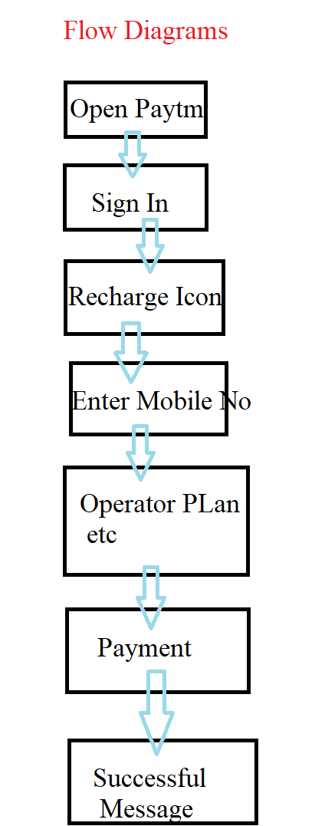**SRS Documents**

* **Functional Flow Diagram.**
* It consist of the All the requirement Flow diagrams of the application/Functionality
* Flow diagram reprints the Flow of the Application9 The steps in which Application navigates)
* **Functional Requirements.**
* All the requirements related to the Application / Software.
* E.g – Facebook Logo, TagLine.
* Email ID and Password Textbox for the Login.
* Login Button Color.
* Create New Account.
* **Forgot Password Button.**

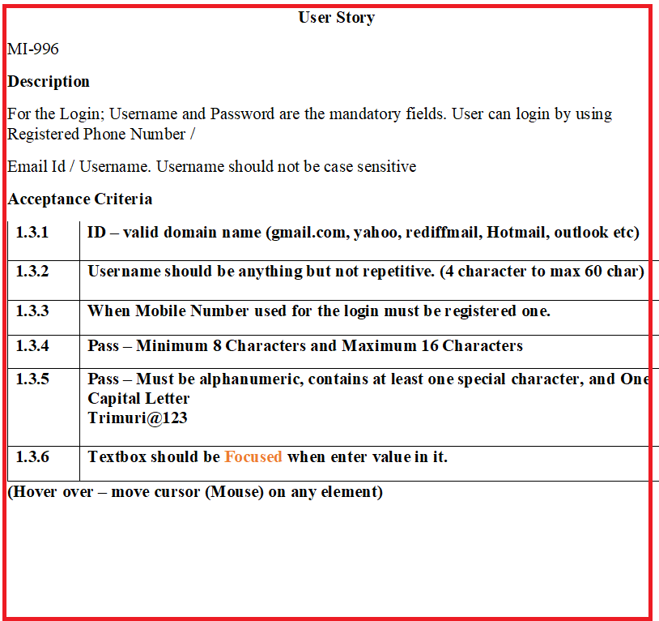

* **User Case. (User Story)**
  + **Description**

Complete detailed information about every single requirement. E.g Forgot Password button should be displayed below the Log in button. Forgot Password? Text should be displayed in blue color and consist of hyperlink.

* + **Acceptance Criteria**

In the Acceptances criteria It consist of Do’s and Don’ts about the user story.

**PASSWORD**

|  |  |
| --- | --- |
| **Accept** | **Reject** |
| 8 – 16 Digit | Less than 8  More than 16 |
| Special Character 1 |  |
| 1 Capital Letter  1 Small Letter  1 Number |  |

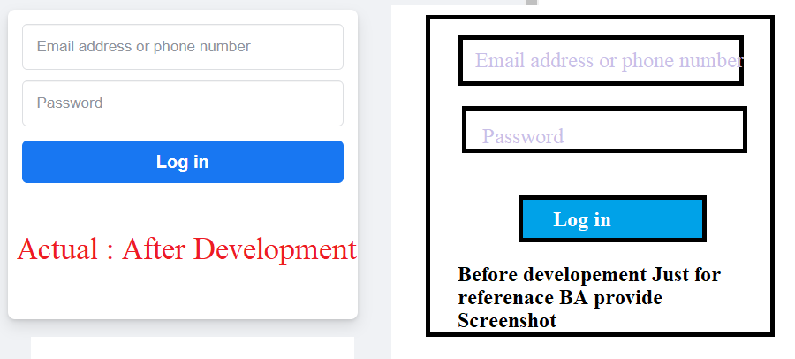

* **Screenshot / Prototype**

Screenshot is a document prepared by BA before the development process so that Developer/Designer can understand the requirement more clearly.

1. **Design**

In the Design phase Designer / Design Architect works.

* 1. High Level Design

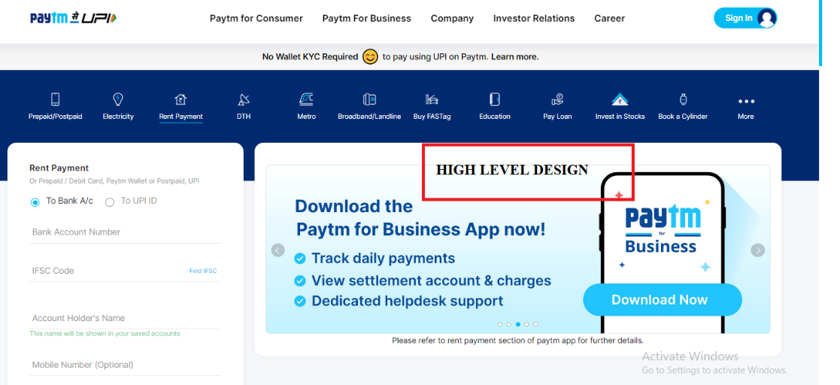

* 1. Low Level Design

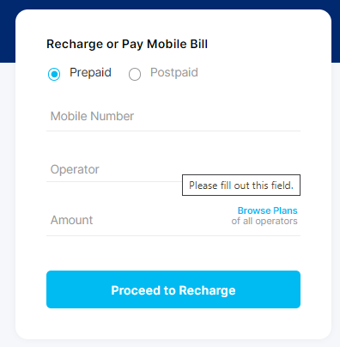

1. **Coding**

* In the Coding phase developers are developing the code against the requirement.
* Logic to be implemented to work the functionality.
* When developers finish the coding Part then Developer will provide a **Build** to the QA.

1. **Testing**

* In the Testing Phase QA performs the different testing on the build(Application) when QA receives the build by dev.
* QA has to Design (Write) Test Cases, Execute the Test Cases and While Testing IF found Bug/Defect then QA has to report a Bug. (Defect Logging)

1. **Maintenance.**

* Work on the existing issue in build/application

**FISH Module**

Information Analysis Design Coding Testing Support/Maint.

Gathering (BRS) (SRS) (HLD, LLD) (LLD) (BBT)

Review Review Review WBT BBT

Static Testing/ **Verification** Dynamic Testing/ **Validation**/

Quality control Quality assurance

**Review: Review is the Process where documentation (Activities) is to be checked.**

* When **BRS** document is prepared by the **BA**, **Client will check** the prepared **BRS** document.
* In the Analysis when **SRS** document is prepared by **BA**, **Client will check** the prepared **SRS** document.
* In the Design Phase, **Designer** will create a **Design**;🡪 **BA, PM and Client -🡪 will review the design.**
* In the Coding Phase 🡪 Developer will write the Code 🡪 **Designer will review** the Code of Developer. + Developer will check the Code and Run his code in Development Env (White Box Testing) 🡪 developer will check the Code.

|  |  |
| --- | --- |
| **White Box Testing** | **Black Box Testing** |
| Perform by developer | Perform by QA |
| In the WBT, Dev will check the Logic, loops, conditions, etc. code part. | In the BBT, QA will perform the different Testing. |
| 1. Unit Testing. 2. Integration Testing. | 1. Smoke / Sanity Testing. 2. Functional and Non Functional Testing. 3. Retesting and Regression Testing. |
| WBT is also known as Code Level Testing. | BBT is also known as System and Functionality Testing. |

|  |  |
| --- | --- |
| **Static Testing** | **Dynamic Testing** |
| In the Static Testing BA will confirm the BRS and SRS Document from the Client. | QA will test the Application using system and functionality Testing |
| Static Testing is also known Verification / Quality Control / In progress Testing | Dynamic Testing also known as Validation/ Quality Assurance/ End Progress Testing |

**Verification**

* Verification is the process which confirms whether the Application/build meet the specification.
* It includes checking the document, design programs etc.
* It consist of method like review, walkthrough/inspections, White box testing.

**Validation.**

* Validation is the process which confirms whether the application /software meet the requirement.
* In the Validation part QA check/confirms whether the requirement is fulfill according to the product/application need.
* QA performs Black Box Testing for the Validation.

------------------------------------------------------------------------------------------------------------------

Interview Questions

1. What is SDLC
2. What is Difference between SDLC and STLC(Manual Part – 2)
3. When QA will start Testing?
4. What is difference between WBT and BBT?
5. What is difference between Static Testing and Dynamic Testing?
6. What is difference between Verification and Validation?
7. What is your Team size?
8. How many developers are working in your team?

---------------------------------------------------------------------------------------------------------------------

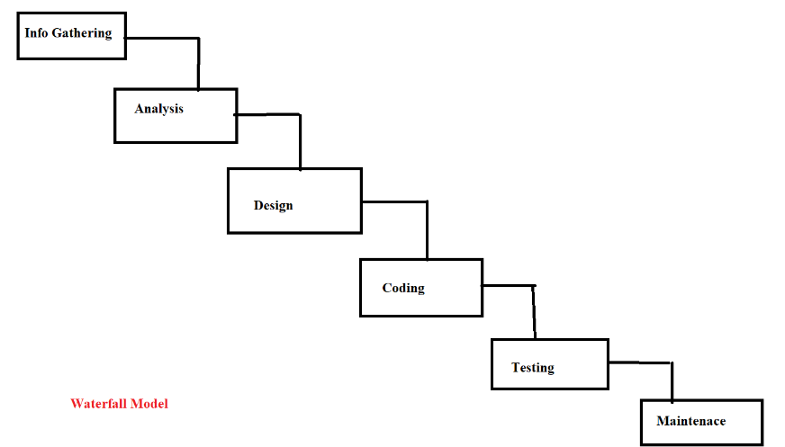**Waterfall Model**

* Waterfall model is **sequential model** for software development and testing.
* i.e after completion of one phase then another phase/stage will start.
* If we found any defect while testing at that time QA will not send back to dev.

**Disadvantages.**

* Deployment Time / **Delivery time is not fixed** in the waterfall model. (min 3 months)
* Back track is not possible.

**Advantage.**

* When the requirement is **small**, **clear** and **constant** (Requirement is not continuously changing) at that time we can use waterfall model.
* When the Budget of the Project is less / Project – Short.
* Waterfall model is used when your **application is not complex.**

---------------------------------------------------------------------------------------------------------------------

**V-Model**

**LCD (Life cycle development) LCT (Life cycle Testing)**

**Verification Validation**

Information gathering (**BRS**) Assessment of development plan.

Analysis (**SRS**) **pdf format**. Prepare test plan.

Requirement Testing/ Understand.

Design (**HLD**, **LLD**) Design phase testing (Review)

Coding (**LLD**- dev. team) Program phase testing (**WBT**)

Test case design (**TCD**)

Install **Build**/ Application System & Function testing (**BBT**) – (**TCE**) -> Pune

User acceptance testing (**UAT**) -> USA (Client side)

Knowledge transfer (**KT**)

**Maintains**/ Support **CR** (Change request)/ **Post Mortem testing**

**DRE** (defect removal efficiency).

* V-Model stands for Verification and Validation.
* The drawback of the waterfall model **Deployment/Delivery Time is not fixed and Backtrack** is not possible are overcome in the in the V Model.
* In the V-Model Verification stages are mapped with the Validation stages.
* Verification and Validation running in parallel.
* In the V-Model Delivery or Deployment **Time is fixed (3 Months.)**
* When one stage is completed and another stage running if there is change in Completed stage then we can accept the change i.e Backtrack is possible in the V-Model.
* Company will charge extra for the Change Request.
* V-Model is **PLAN** driven model.

**Dis-advantage.**

* **Time is fixed (3 Months.)**

---------------------------------------------------------------------------------------------------------------------

**Assessment of development plan.**

* In the Assessment of development plan, Strategy for the Testing is decided.
* E.g Testing – Manual /Automation
* TRM (Test Responsibility Matrix) document will create in this stage.

**Test Plan Preparation**

* In the Test Plan preparation – Planning required for the Testing (Test Plan) decides.
* E.g No of QA (4QA – 1 Automation Expert : Only Automation, 1 Manual QA: Perform only Manual, 2 QA – Automation + Manual)
* Distribute the work to team.

**Requirement Understanding.**

* In this stage Requirements in the SRS documents will understand.
* E.g Google Meet Module – 200 People can Join, Mute Unmute Functionality, Hand Raise Functionality.

-------------------------------

**Design phase testing (Review)**

* After the Design (HLD and LLD) Design will review by the Client/BA.
* In this testing Design conforms correct or not.
* Designer will have to present Design in meeting (Meeting Consist of Client, BA, Manager and Designer)

**Program phase testing (WBT)**

* When developer finish coding part then Code need to be checked by the Developer.
* This phase consist of Code Testing.
* Developers are involve in this phase.

**Test Case Design**

* When Developers are/start coding; at the Time QA will start Design the Test Cases.
* QA involves in this stage.

---------------------------------

BBT - Black Box Testing – QA Performs Testing. (System and Functionality Testing)

UAT – User Acceptance Testing (QA Testing).

KT: Knowledge Transfer: - Training provided to the QA.

----------------------------------

**CR (Change request)**

E.g : Recharge Successful 🡪 “Recharge Successful”

“Recharge Successful” changed to 🡪 “Recharge Successful, Thanks for Using Paytm”

Defect Removal Efficiency (DRE)

* DRE is used to checked how thourouly your application is tested.
* DRE is calculated using the Formula :

DRE = (A) / (A+B) = 5/6 = 100%

Where

A = No of Bug find in SIT

B =No of Bug find in UAT

|  |  |  |  |
| --- | --- | --- | --- |
| DRE | 0.8 to 1 | 0.6 to 0.8 | Below 0.6 |
| Remark | Good Testing | Average Testing | Poor Testing |

--------------------------------------------------------------------------

**Agile Methodology.**

* Agile method defines it **is Continuous and Iterative** process of software development and Testing.
* Agile follow **incremental approach.**
* Agile is a **Value driven process** i.e Complete priority (Importance) is given to the client
* In the Agile Methodology **requirements are continuously changing**.
* If **CR** is given by the Client then we will **surely accept the change request** but we will **analyze** **the impact of the CR** on current development and testing process.
* If the Impact of CR is higher then we will inform that Impact to the Client
* If the Impact of CR is less then we will accept the change and proceed further.

**Advantages of Agile**

1. Deployment time in the Agile is fixed (2/3/4 Weeks) 🡪 **2 WEEKS**
2. It is a **Continuous** process and follows **Incremental** approach.
3. Agile has Different Meetings.

* Grooming Meeting.
* Sprint Planning Meeting.
* Daily Stand Up Meeting.
* Demo Meeting.
* Sprint Retrospective Meeting.

Disadvantages

* G

Sprint

